Small Business Management

*Submitted in partial fulfilment of the requirements*

*For the degree of*

**Bachelor of Technology**

(*Computer Science Engineering*)

Submitted By:

Anoushka Raizada (A70405220028)

Charusee Yadav (A70405220003)

Under the Guidance of

**Dr. Soni Sweta**



**AMITY SCHOOL OF ENGINEERING AND TECHNOLOGY**

**AMITY UNIVERSITY MUMBAI**

**2021-22**

Table of Content

|  |  |  |
| --- | --- | --- |
| Sr. No | Content | Page No |
| 1. | Introduction | 3-4 |
| 2. | E-R Diagram | 5 |
| 3. | Database Tables (MySQL) | 6-8 |
| 4. | Frontend (Python) | 9-13 |
| 5. | Bibliography | 14 |

Introduction

A database is a collection of related data which represents some aspect of the real world. A database system is designed to be built and populated with data for a certain task. **Database Management System (DBMS)** is a software for storing and retrieving users’ data while considering appropriate security measures. It consists of a group of programs which manipulate the database. The DBMS accepts the request for data from an application and instructs the operating system to provide the specific data. In large systems, a DBMS helps users and other third-party software to store and retrieve data. DBMS allows users to create their own databases as per their requirement. The term “DBMS” includes the user of the database and other application programs. It provides an interface between the data and the software application.

* **MySQL** is a relational database management system (RDBMS) developed by Oracle that is based on structured query language (SQL).
* **Python** is an interpreted high-level general-purpose programming language. Its design philosophy emphasizes code readability with its use of significant indentation. Its language constructs as well as its object-oriented approach aim to help programmers write clear, logical code for small and large-scale projects.

* **HTML (Hypertext Markup Language)** is the code that is used to structure a web page and its content. For example, content could be structured within a set of paragraphs, a list of bulleted points, or using images and data tables.
* **CSS** stands for Cascading Style Sheet.CSS is the language we use to style an HTML document. CSS describes how HTML elements should be displayed.
* **JavaScript** is a light-weight object-oriented programming language which is used by several websites for scripting the webpages. It is an interpreted, full-fledged programming language that enables dynamic interactivity on websites when applied to an HTML document.
* **Small Business Management**

The definition of a small business is an independently owned and operated company that is limited in size and in revenue depending on the industry.

Like an example of a local bakery that employs 10 people.

Small businesses are those which are not known to many people and are opened on any social media. People making things and working from home, this actually came to people’s knowledge since during pandemic lot of people lost their jobs. These small businesses are mostly coming to not only existing but also in people’s eye through all the social media platform which was our only way to communicate with other people during pandemic.

E-R Diagram

Searches in

Customer_ID

Location

Password

Email

Customer_Name

customer

password

Name

B_no

owner

Business

Owner

B_Name

B_description

B_no

business

Media_Acc

Location

Database Tables

(MySQL)

1. Table 1- business

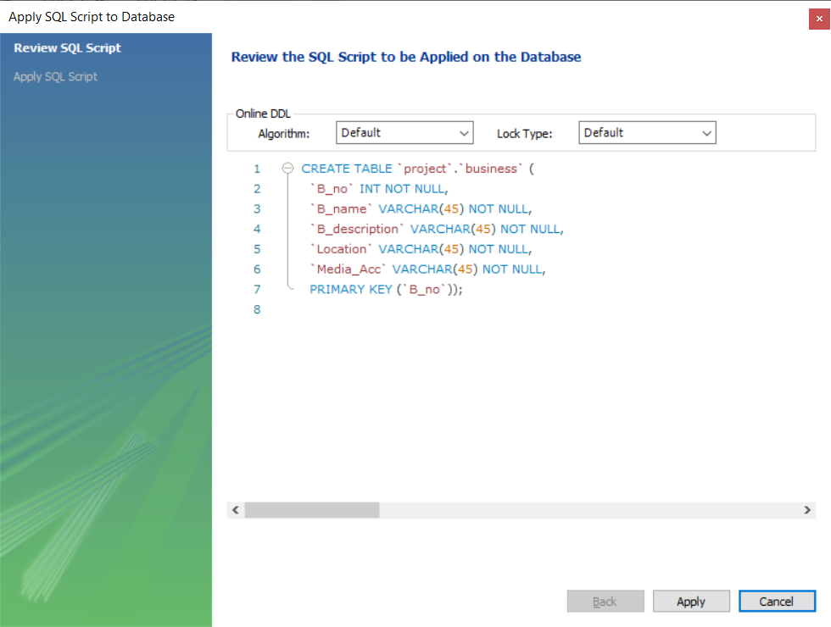

1. B_no - Which is a primary key in the table, it is given to every business for them to make search of their business easy.
2. B_name – Which the name of the business given by the people who own it.
3. B_description – Giving the details or naming their products for searching processes.
4. Location – To make it easier for buyers to buy from the business nearer to their location for fast shipping.
5. Media_Acc – It is basically them providing the place where their business exists, it might be a website name or their usernames on any social-media platform.

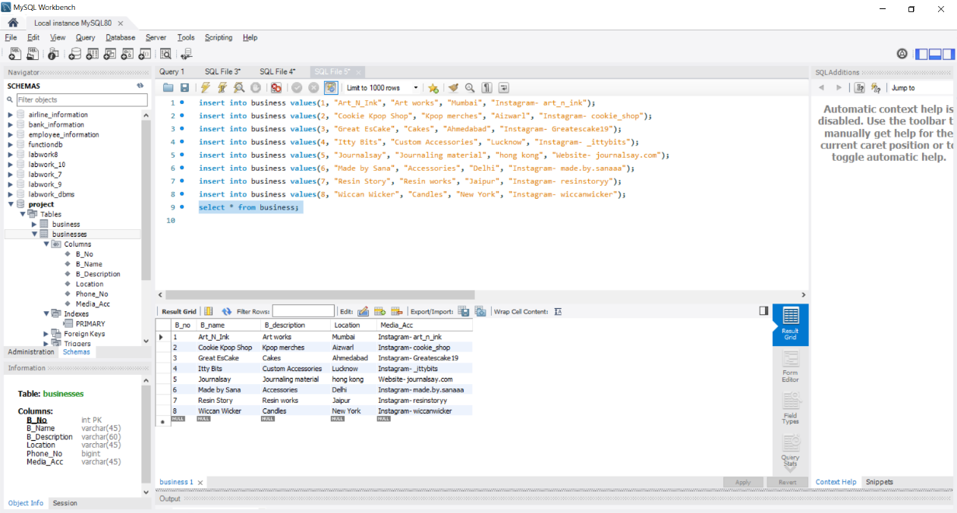

1. Table 2- owner

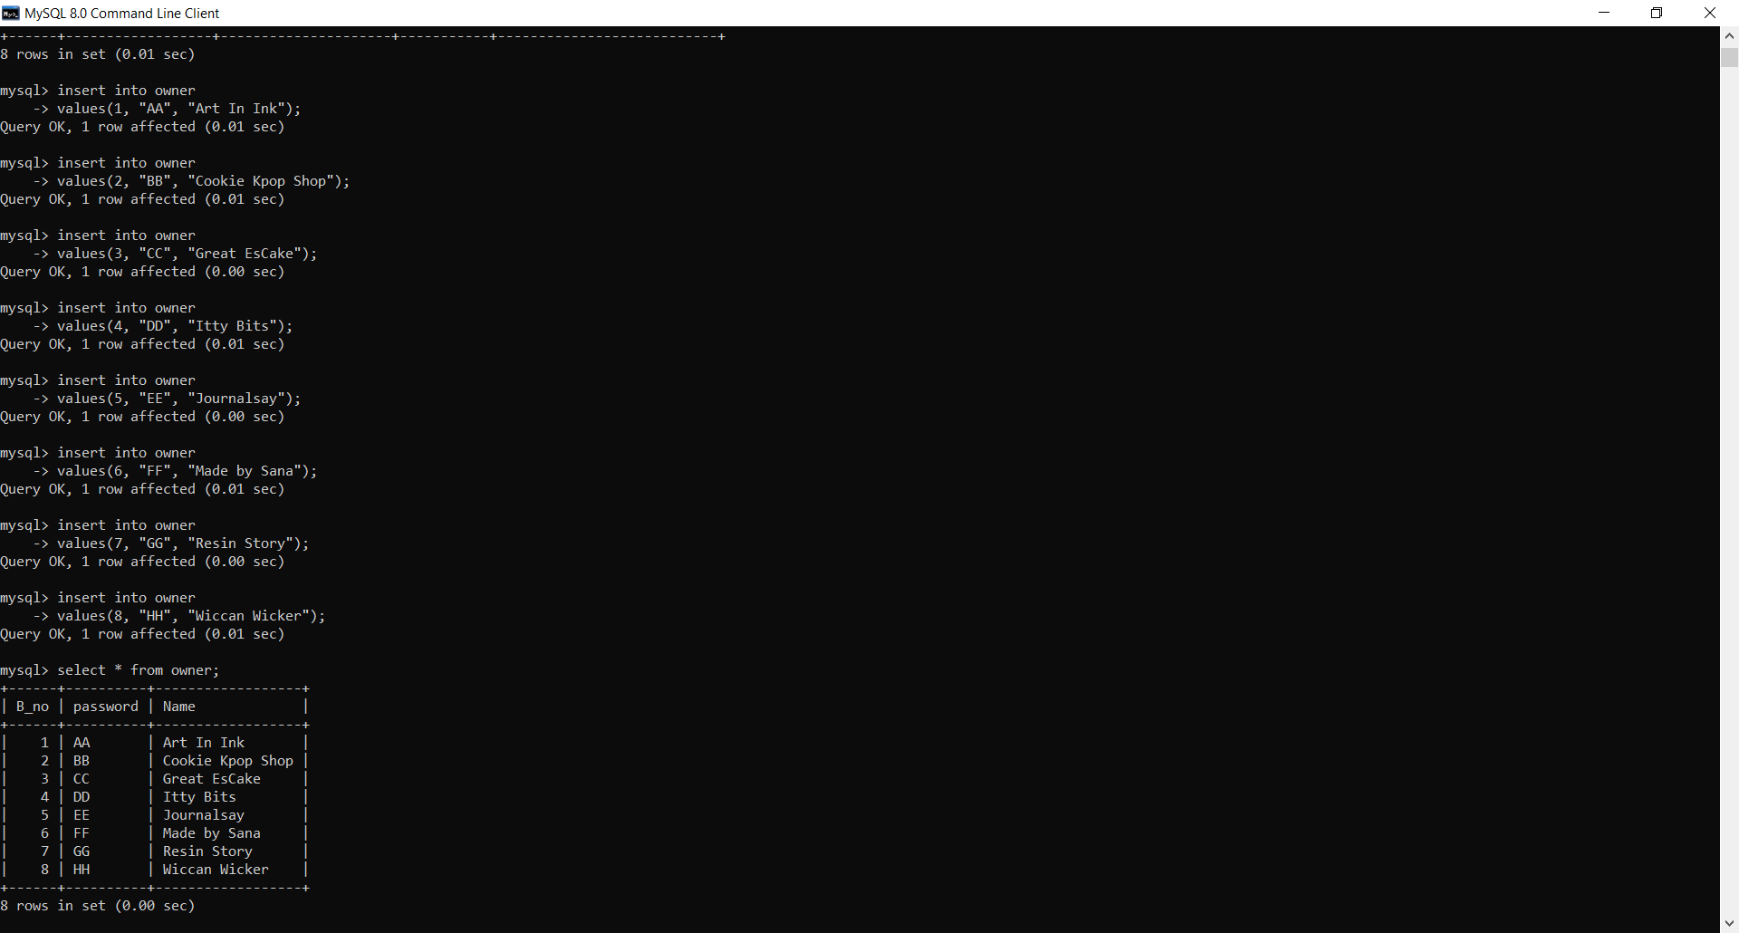

1. B_no – This is the business number given to the owner given by us during adding new business.
2. Password – This is will help in login the owner as not everyone can know the password and make any changes or use any function of provided to owner.
3. Name – The name is corresponding to the business number given by the owner.
4. Table 3- customer

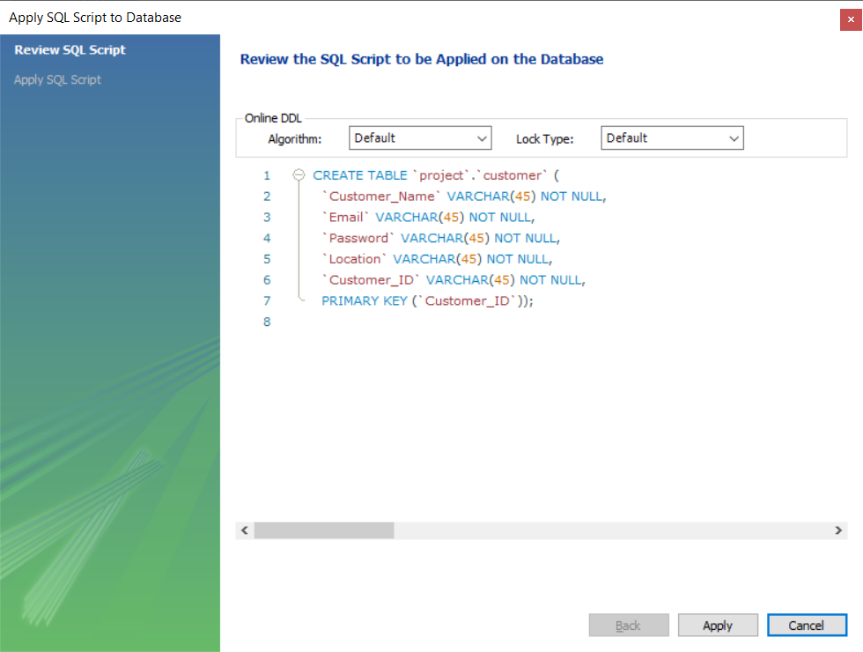

1. Customer_Name – The name of the customer.
2. Email – Email for us to provide them with any details in future.
3. Password – Password required for them to enter into our website.
4. Location – Location of the customer for us to provide them options near them.
5. Customer_ID – This is basically the username; the customer opts for themselves which should be unique for the database to know them as specific person.

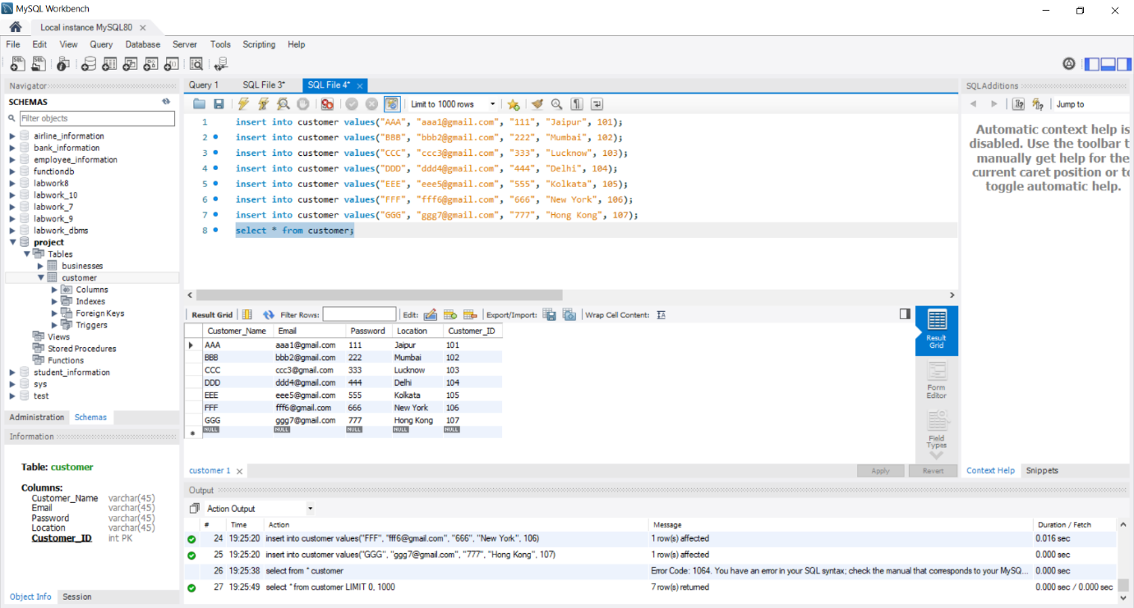

Frontend

(Python)

Main menu:

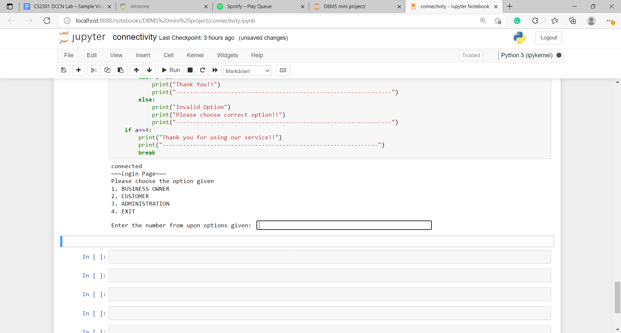

1. Business Owner Option

* After the business owner is logged in, these options are available for them.

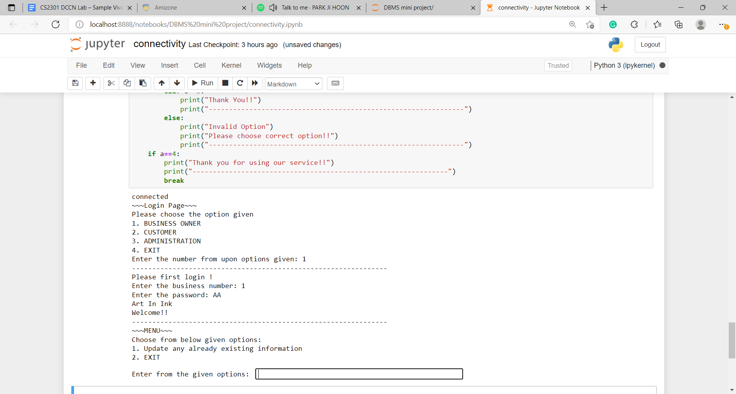

1. Updating the already information in the database

* There are four option avaiable for them to change.

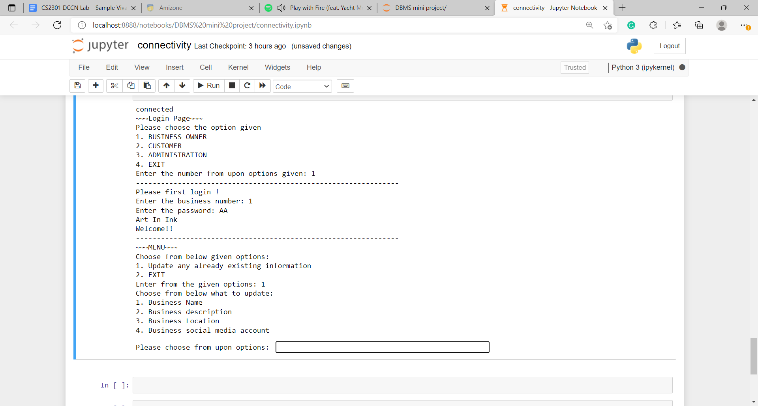

1. Exit

* After exiting, it will again give option to choose from them.

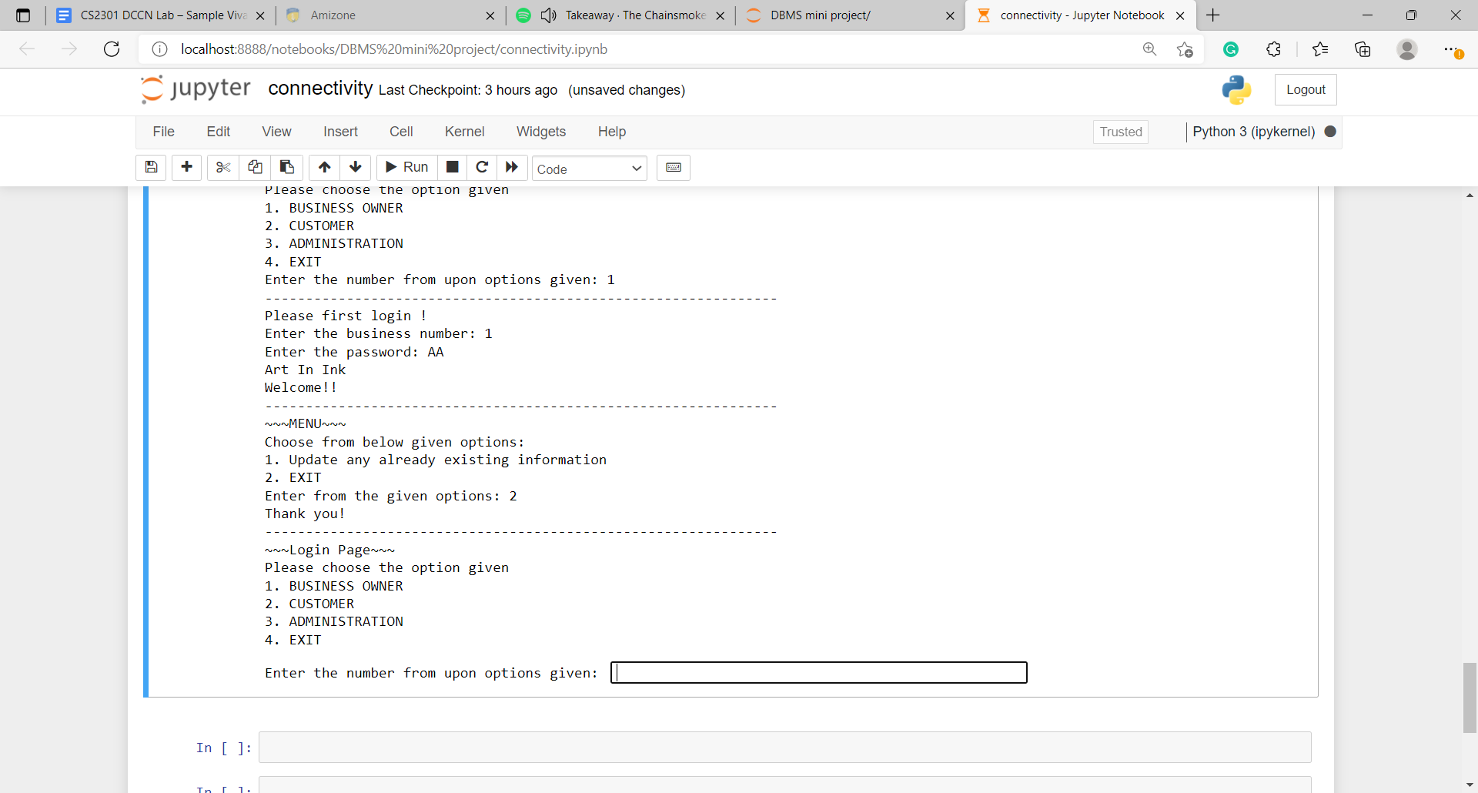

1. Customer Option

* After choosing customer option, they need to login. Then they get three options to choose.

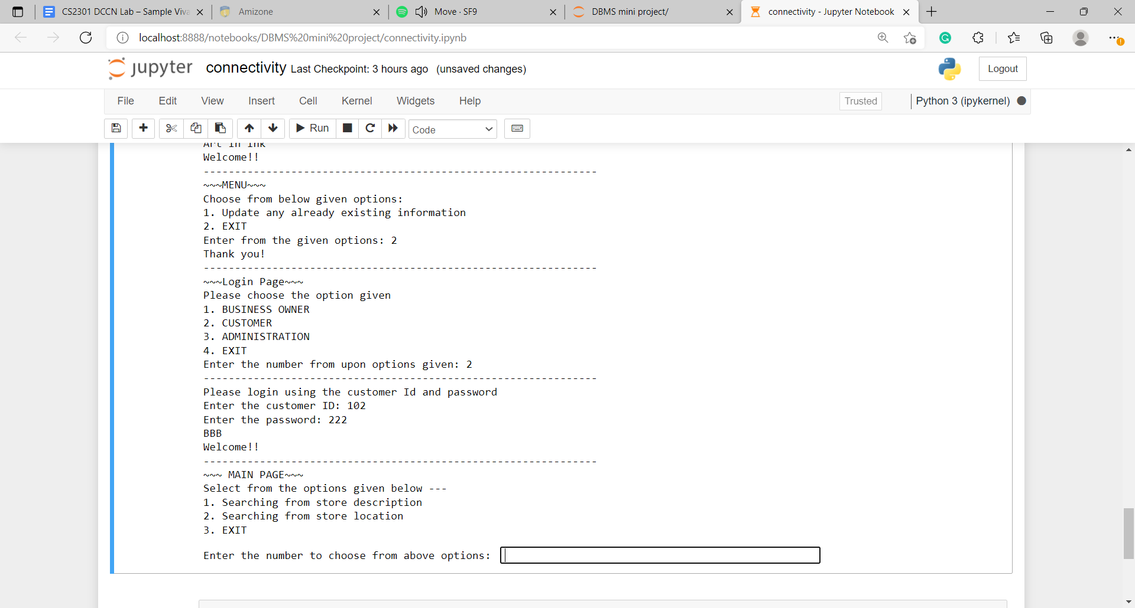

1. Searching from store description

* It will give you the store you are looking for on the basis of what you want to buy. And then Main menu will open again.

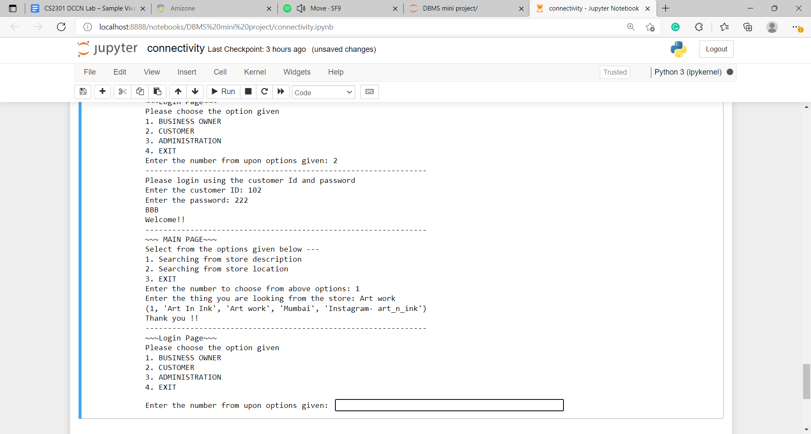

1. Searching from store location

* It will give you the store you are looking for on the basis of which place you are looking. And then Main menu will open again.

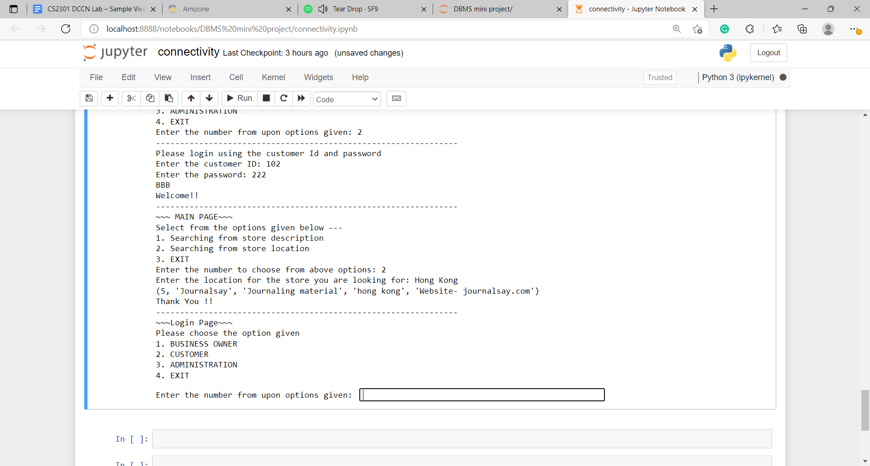

1. Exit

* This option will let customer exit even without searching anything. And Main Menu will open again.

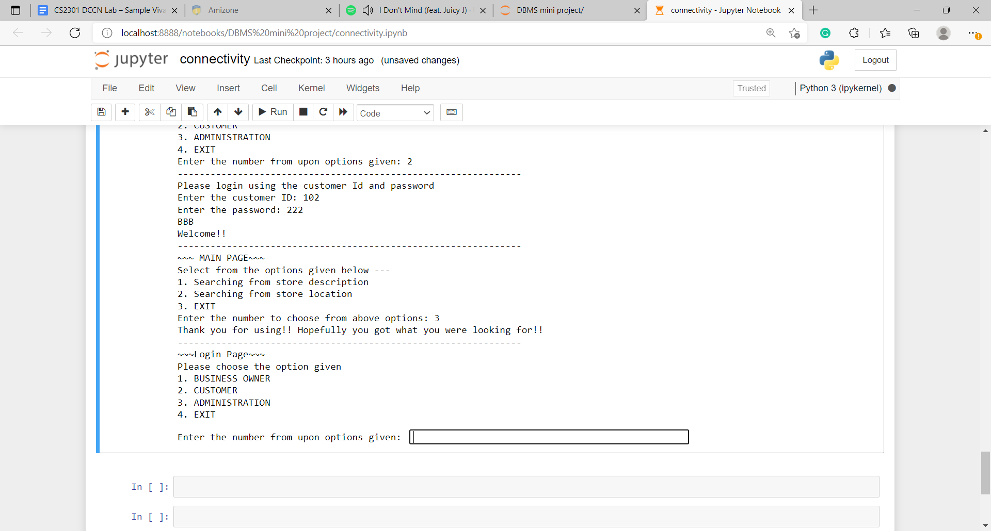

1. Administration Option

* This option is from the ones who are managing the whole database. And provide 3 options.

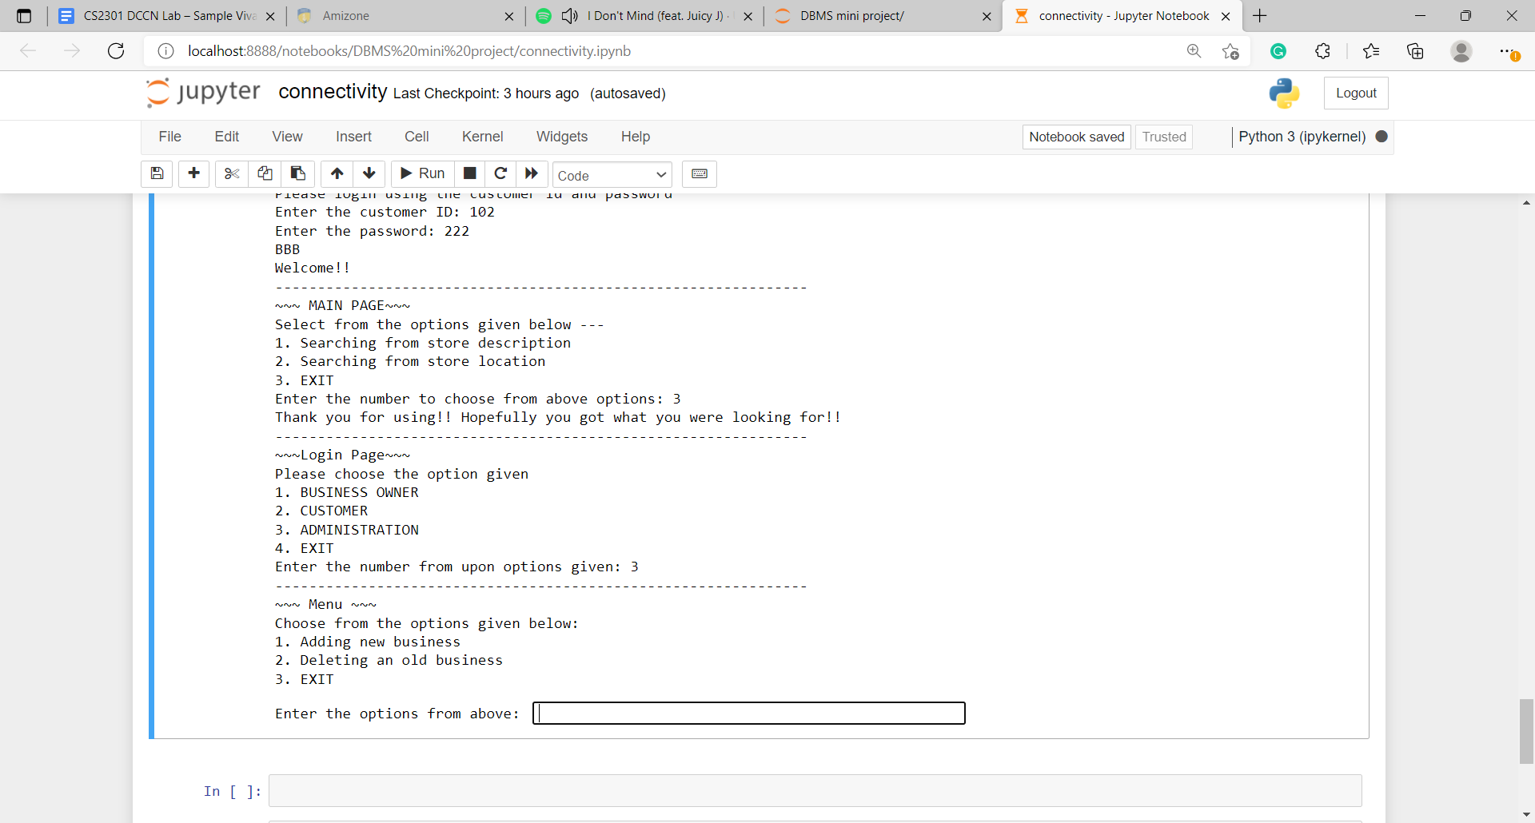

1. Adding new business

* It is for adding new small business and adding business owners in the database.

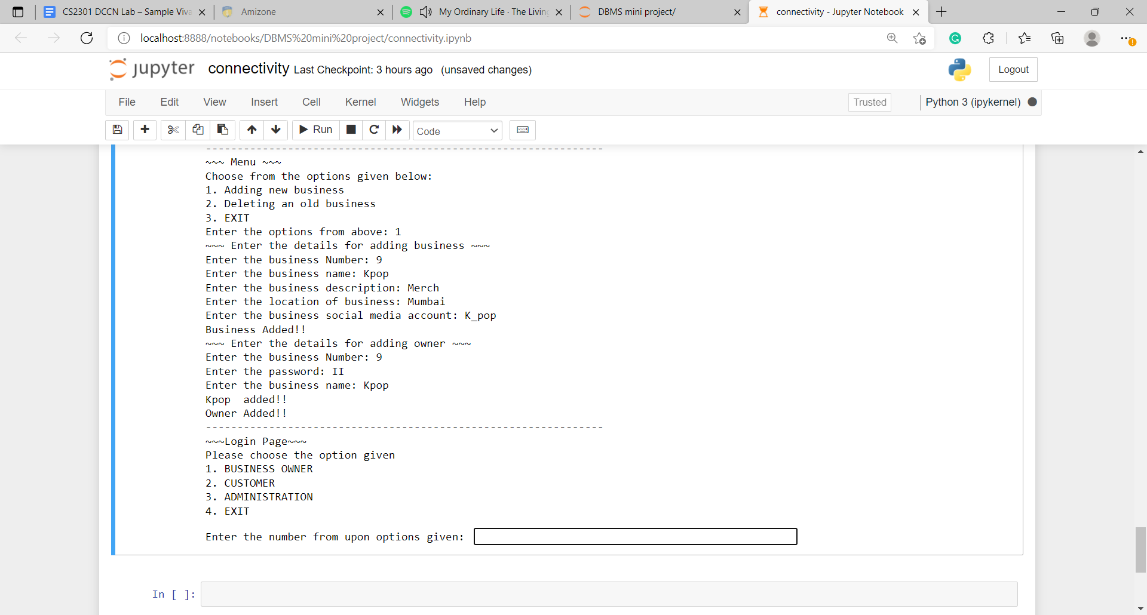

1. Deleting the already existing old business in the database.

* It will delete the business as well as owner from database.

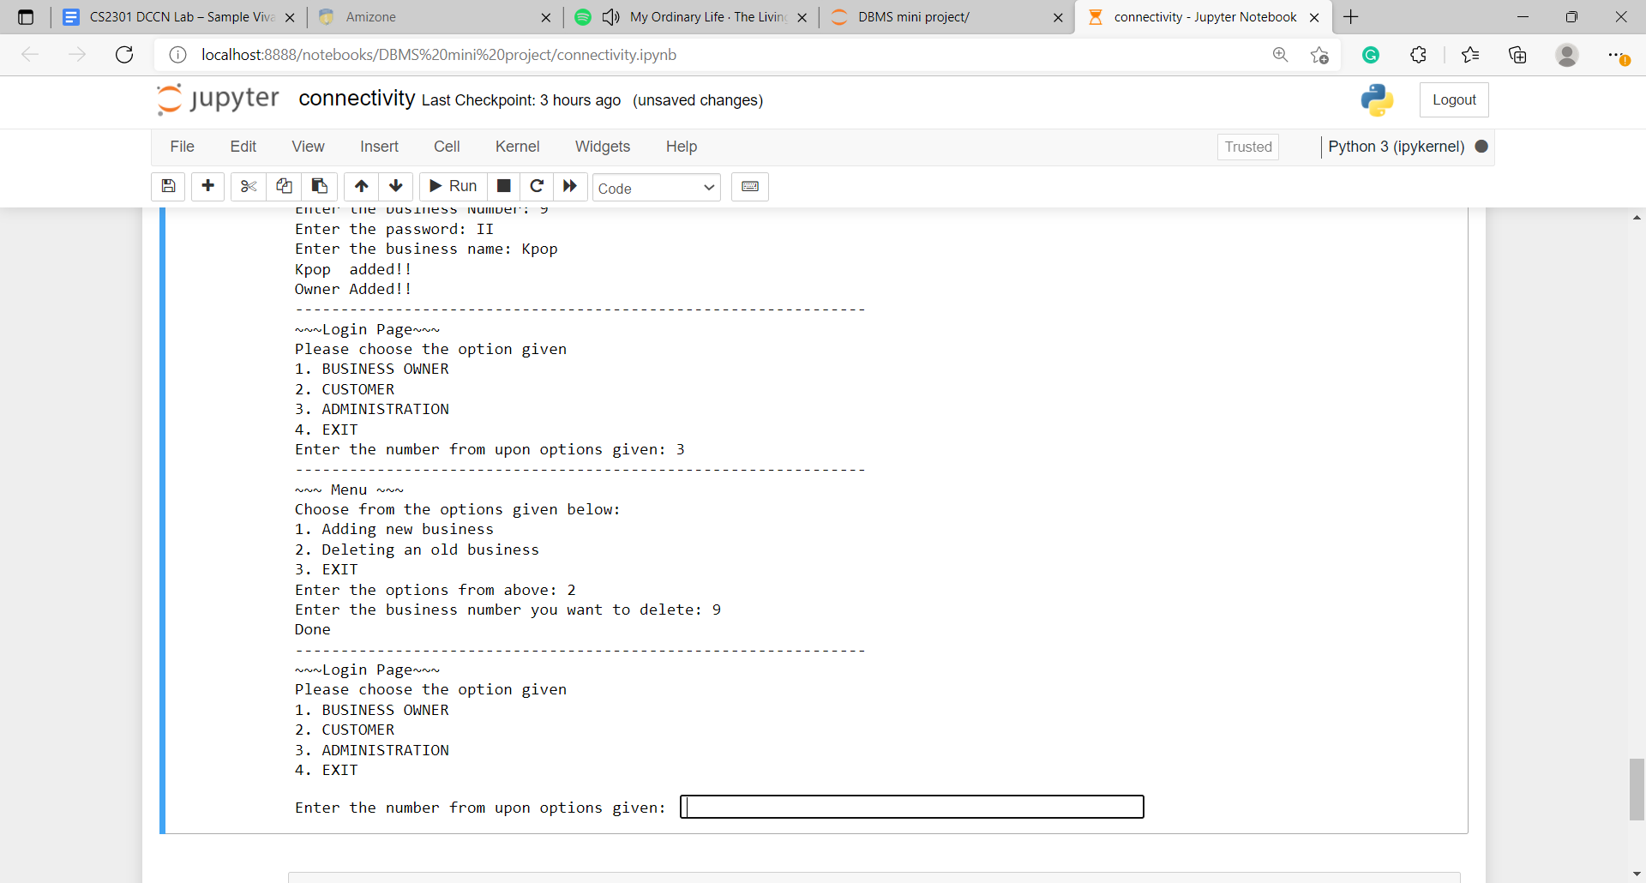

1. Exit option

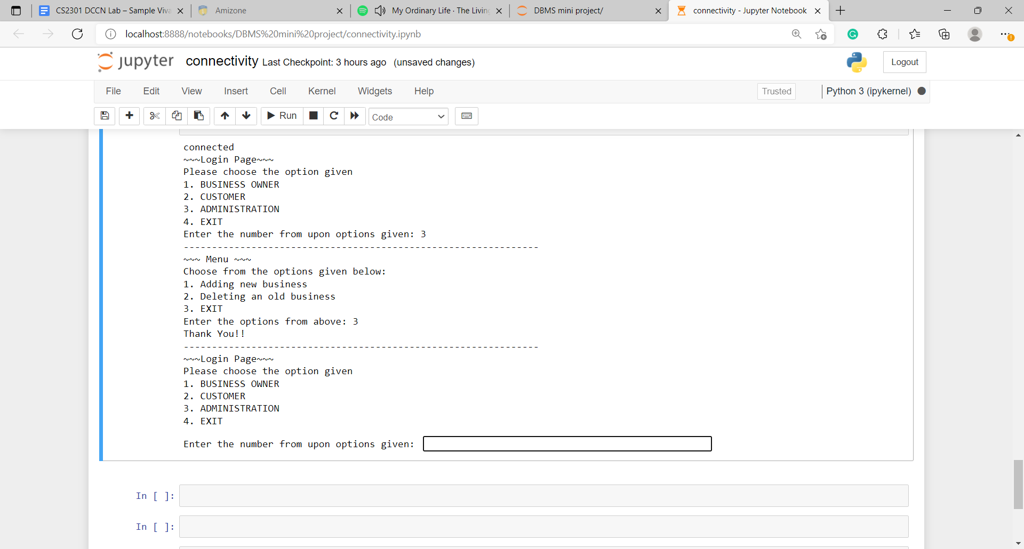

1. EXIT Option

* This will help to logout from whole system in total.

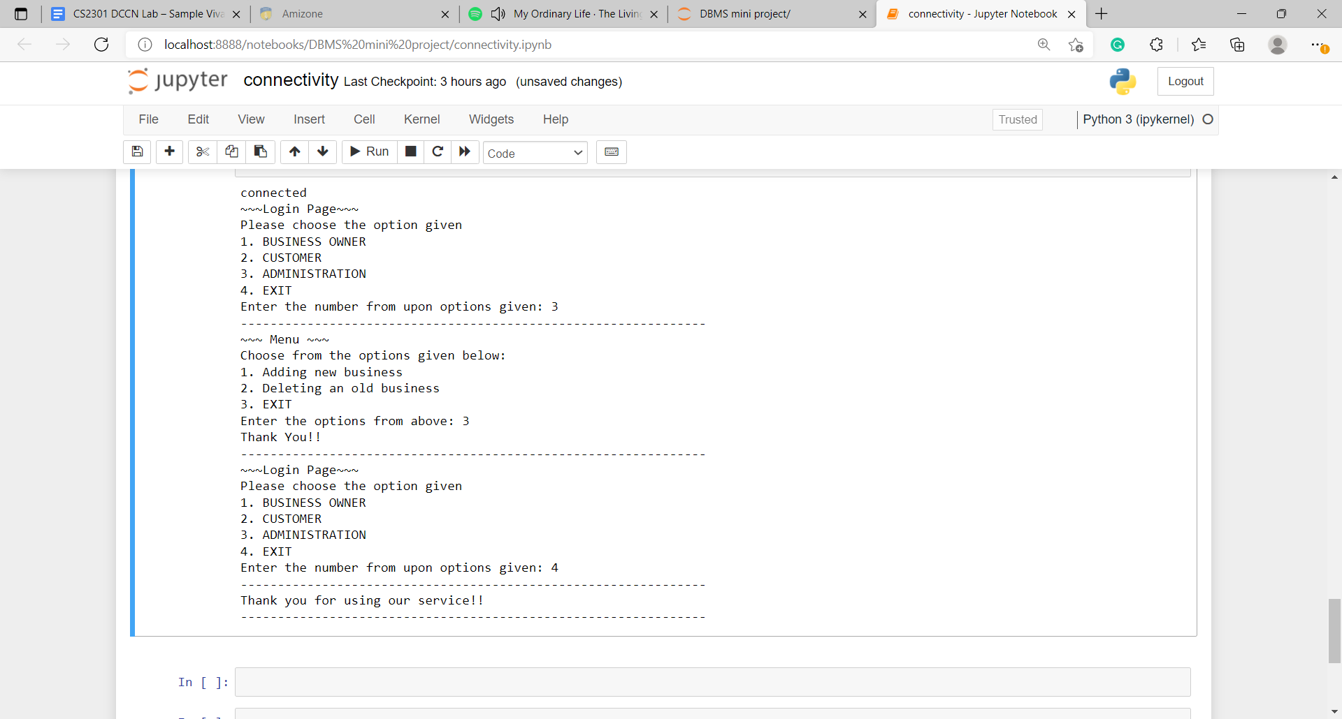

Bibliography

1. https://www.w3schools.com/html/
2. https://www.w3schools.com/css/
3. https://www.youtube.com/c/EasyTutorialsVideo
4. Computer Science with Python by Sumita Arora

(Textbook for Class XII)

Thank

You!